**Lab Practical #01:**

Study of basic networking commands and IP configuration.

**Practical Assignment #01:**

1. Perform and explain various networking commands listed below:
   1. ipconfig
   2. ping
   3. getmac
   4. systeminfo
   5. traceroute / tracert
   6. netstat
   7. nslookup
   8. hostname
   9. pathping
   10. arp

**- - - Commands Below - - -**

## ipconfig

### Description:

ipconfig is a Windows command-line tool used to view and manage the network configuration of your system. It displays details like the IP address, subnet mask, and default gateway for each network adapter. You can also use it to refresh DHCP leases or clear and renew DNS information.

|  |  |  |
| --- | --- | --- |
| No. | Option | Description |
| 1 | /all | Displays complete network configuration details, including MAC address, DHCP, and DNS settings. |
| 2 | /release | Releases the current DHCP-assigned IP address. |
| 3 | /renew | Requests a new IP address from the DHCP server. |

### Implementation:

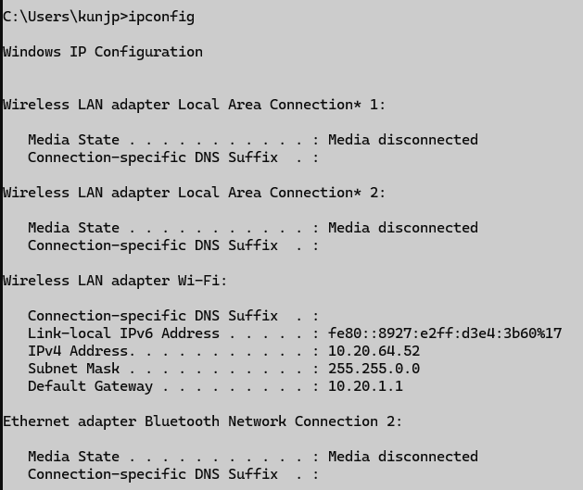

## ping

### Description:

ping is used to test the connectivity between your computer and another device or server on a network. It sends small packets of data (ICMP Echo Requests) and measures how long it takes for them to return, helping to identify latency and network issues.

|  |  |  |
| --- | --- | --- |
| No. | Option | Description |
| 1 | -n <count> | Specifies the number of echo requests to send. |
| 2 | -t | Pings the target until stopped manually (Ctrl + C). |
| 3 | -l <size> | Specifies the size (in bytes) of the ping packet. |
| 4 | -4 | Forces the command to use IPv4. |
| 5 | -6 | Forces the command to use IPv6. |

### Implementation:

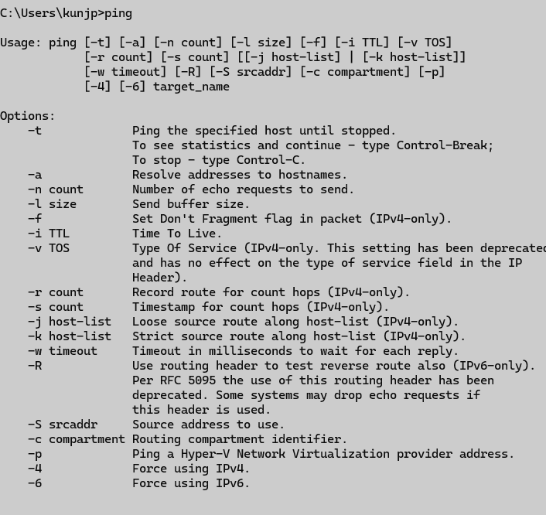

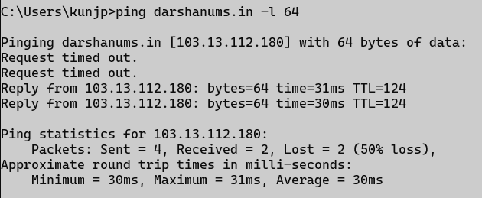

## getmac

### Description:

getmac displays the MAC (Media Access Control) address of your network adapters. A MAC address is a unique identifier assigned to each network interface card.

|  |  |  |
| --- | --- | --- |
| No. | Option | Description |
| 1 | /v | Displays detailed information in verbose format. |
| 2 | /fo LIST | Displays output in a list format. |
| 3 | /fo TABLE | Displays output in a table format (default). |
| 4 | /fo CSV | Displays output in CSV (comma-separated) format. |
| 5 | /nh | Hides the column headers in the output. |

### Implementation:

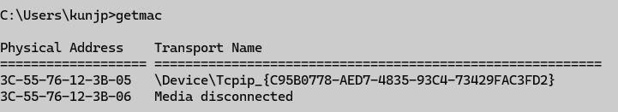

## systeminfo

### Description:

systeminfo displays detailed information about your computer’s hardware and operating system, such as OS version, processor, memory, and network configuration.

|  |  |  |
| --- | --- | --- |
| No. | Option | Description |
| 1 | /s <computer> | Specifies the remote computer to query. |
| 2 | /u <user> | Specifies the user account to use for the remote connection. |
| 3 | /p <password> | Specifies the password for the user account. |

### Implementation:

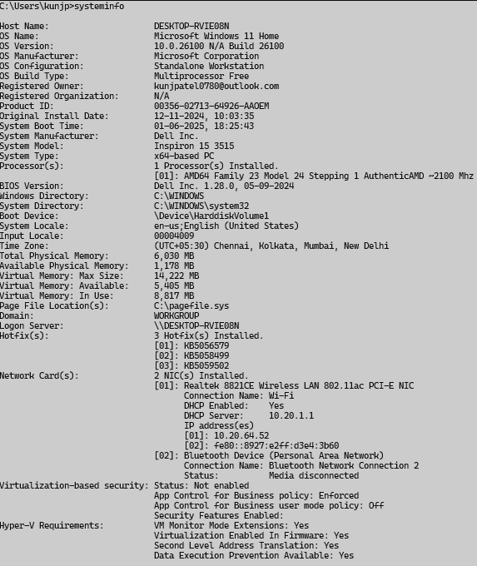

## traceroute (Windows)/tracert (Linux/Mac)

### Description:

This command traces the path that packets take from your computer to a destination. It shows each hop (router) along the way and the time taken for each hop, helping to diagnose routing problems.

|  |  |  |
| --- | --- | --- |
| No. | Option | Description |
| 1 | -d | Prevents resolving IP addresses to hostnames. |
| 2 | -h <maxhops> | Sets the maximum number of hops to search for the target. |
| 3 | -w <timeout> | Sets the timeout in milliseconds for each reply. |
| 4 | -4 | Uses IPv4. |
| 5 | -6 | Uses IPv6. |

### Implementation:

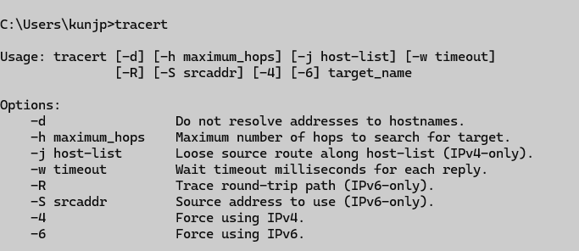

## netstat

### Description:

netstat displays active network connections, routing tables, interface statistics, and more. It’s useful for checking open ports and active connections.

|  |  |  |
| --- | --- | --- |
| No. | Option | Description |
| 1 | -a | Displays all active connections and listening ports. |
| 2 | -n | Shows addresses and port numbers in numerical form. |
| 3 | -o | Displays the process ID (PID) associated with each connection. |
| 4 | -b | Shows the executable file for each connection (requires admin rights). |
| 5 | -r | Displays the routing table. |

### Implementation:

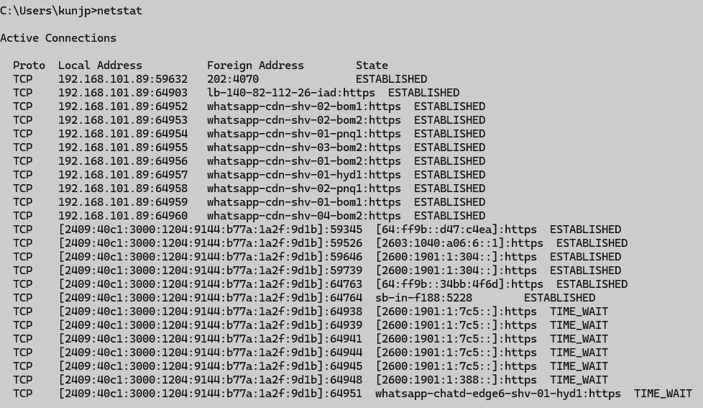

## nslookup

### Description:

nslookup queries the Domain Name System (DNS) to obtain domain name or IP address mapping. It’s used for DNS troubleshooting.

|  |  |  |
| --- | --- | --- |
| No. | Option | Description |
| 1 | <hostname> | Looks up the IP address for a specific domain name. |
| 2 | <IP> | Looks up the domain name for a specific IP address (reverse lookup). |

### Implementation:

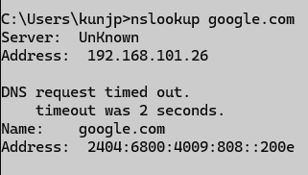

## hostname

### Description:

hostname displays the name of the computer you’re currently using on the network.

### Implementation:



## pathping

### Description:

pathping combines the functions of ping and tracert. It traces the path to a destination and also measures packet loss at each hop, making it useful for pinpointing network issues.

|  |  |  |
| --- | --- | --- |
| No. | Option | Description |
| 1 | -n | Prevents resolving IP addresses to hostnames. |
| 2 | -h <maxhops> | Sets the maximum number of hops to search for the target. |
| 3 | -g <hostlist> | Specifies loose source routing. |

### Implementation:

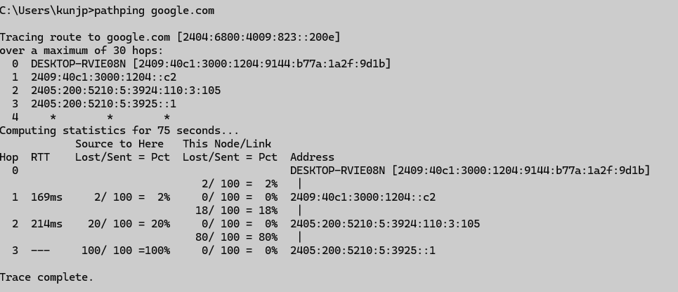

## arp

### Description:

arp displays and manages the Address Resolution Protocol cache. The ARP cache stores mappings between IP addresses and their corresponding MAC addresses.

|  |  |  |
| --- | --- | --- |
| No. | Option | Description |
| 1 | -a | Displays the current ARP table. |
| 2 | -g | Same as -a, shows ARP table entries. |
| 3 | -d <IP> | Deletes the ARP entry for a specified IP address. |

### Implementation:

